**Mini Project Report On**

**“Pay N Split”**

**submitted in partial fulfillment of the requirements for the award of the degree of**

**BACHELOR OF ENGINEERING**

**(Computer Engineering)**

**By**

**1. Mayur Chinche Roll No: 39018**

**2. Sairam B Roll No: 39004**

**3. Viren Varma Roll No: 39079**

**4. Rajratnam Shetty Roll No: 39071**

**UNDER THE GUIDANCE OF**

**Mr. Santosh Nagargoje**



**Department of Computer Engineering**

**PES’s Modern College of Engineering, Pune-05**

**2019-2020**



**Department of Computer Engineering**

**Progressive Education Society’s**

**Modern College of Engineering, Shivajinagar, Pune-05**

***CERTIFICATE***

***This is to certify that the project entitled***

***“Pay N Split”***

***Submitted by***

**1. Mayur Chinche Roll No: 39018**

**2. Sairam B Roll No: 39004**

**3. Viren Varma Roll No: 39079**

**4. Rajratnam Shetty Roll No: 39071**

***is a bonafide account of the work done by him/her under our supervision.***

**Project Guide/Internal Examiner HOD**

**Mr. S. N. Nagargoje Prof. Dr. Mrs. S.A. Itkar**

**External Examiner**

**ACKNOWLEDGMENT**

I take this opportunity to express my profound gratitude and deep regards to my guide Mr. Santosh Nagargoje for his exemplary guidance, monitoring and constant encouragement throughout the course of this project. The blessing, help and guidance given by him time to time shall carry me a long way in the journey of life on which I am about to embark.

I also take this opportunity to express a deep sense of gratitude to Prof. Dr. Mrs. S. A. Itkar (Head of Department) for her cordial support, valuable information and guidance which helped me in completing this task through various stages.

I am obliged to staff members of PES MCOE, for the valuable information provided by them in their respective fields. I am grateful for their cooperation during the period of my assignment.

Lastly, I thank the almighty, my parents and my classmates for their constant encouragement without which this assignment would not have been possible.

**ABSTRACT**

Pay N Split is designed to be a versatile bill-splitting app to fit most situations where you need to split costs between multiple people. You can create groups with various friends and divide up what each person owes. All your shared expenses are organized in one place and everyone in the group can see the amount they owe.

The app tracks borrowing and lending over time. And, until the balance is settled up, each person’s outstanding balance may go up and down. This application provides an easy user interface which helps people to manage their expenses and contribution for group activities. This app is easy to learn and efficient to use.

**TABLE OF CONTENTS**

|  |  |  |
| --- | --- | --- |
| **Sr. No** | **Name** | **Page No** |
| **1** | **Introduction** | **1** |
| **2** | **Objectives** | **2** |
| **3** | **Methodology** | **3** |
| **4** | **Software / Hardware requirement** | **5** |
| **5** | **Implementation Details** | **6** |
| **6** | **Future Scope** | **12** |
| **7** | **Conclusion** | **13** |

**INTRODUCTION**

In the past, splitting the cost of bills and expenses was a clumsy process. You had to calculate who owed what, then go through the tedious task of collecting money from each person. And since fewer people are carrying cash less often these days, settling up gets even more difficult. That is, until Pay N Split app.

Pay N Split app lets you divide up the cost of things like group dinners and group trips so that everyone can pay their fair share. With Pay N Split, you’ll be able to keep the peace between friends by cutting down on squabbles about who owes what to whom.

One of the advantages of the app is that it gives you a multitude of payment options like Paytm, UPI and Cash to pay and clear your bills. The user-friendly user interface is also easy to use and adapt.

The app allows you to maintain personal and group transactions separately. This leads to efficient management of one’s expenses. The bill is calculated and every member gets information about how much is his contribution and how much he has to pay or receive.

Pay N Split can be used in a variety of occasions in our life. It can be specifically used between roommates to manage their daily collective expenses for the room.

**OBJECTIVES**

1. Provide a software application for bill splitting.
2. To bring in an easy user interface and interactive application which provides feasible options to users.
3. To manage the expenses of members in a group.
4. To easily collect money from a group.
5. Provide features to easily split expenses among friends.
6. To minimize time for processing of various tasks, thereby reducing the time consumption.
7. To reduce the manual work for members as the calculations are accomplished automatically with the help of application software.
8. This app aims to make shared living simple.

**METHODOLOGY**

We have developed an application for people living in a group to split their bills amongst themselves. The bills can be splitted by the end of the month to ensure that every member of the group contributes his part and receive what he has payed extra. For a new user to use the app, he has to create an account. This can be done by clicking on the Sign-up button. He has to enter his credentials to login to an account which is already existing.

When the user is logged in, he has the option to either create a group or join a group. If the user chooses to create a group, he gets a unique group-id through which he can add members. Users can join a group by using the group-id created by the admin.

The homepage consists of all the groups in which the user is present. The groups can be navigated by using a list. Whenever the user opens a particular group, he is directed to an activity page. The activity page consists of multiple tabs like:

* Pay
* View Transactions
* Add members

The Pay tab redirects you to the payment page where we have various payment options like UPI, Paytm and Cash payment. The user can choose any payment option of his choice and do the transaction. After the transaction is completed, he will be redirected to the app.

The transactions can be viewed in the View Transactions tab. There are two buttons in the tab: Personal and Group. The user can view his personal expenses in the Personal tab and the group expenses can be seen in the group tab. The tab is designed in such a way that the user can easily view and manage his expenses.

We have also included a Bill button in the View Transactions tab. When a user clicks on the button, a bill is generated which shows the Group total, Personal contribution, Per Member contribution and the amount to be paid or received. This tab is helpful as it gives the information about how much one has to pay or receive in a group.

In the Add Members tab, we can share the unique group-id through which new members can join. We can share the group-id through various media like WhatsApp, Messaging, etc.

We have designed this application in such a way that it is accessible to untrained people as well. A navigation pane is also included to easily switch between tabs, hence providing an easy user interface.

* **ARCHITECTURE :**

**APPLICATION**

SERVICE

DATABASE

USER

PAYMENT API

USER INTERFACE

SDK LIBRARY

**SOFTWARE AND HARDWARE DETAILS**

1. Software Requirements:

* Android Studio
* Firebase
* Ubuntu

1. Hardware Requirements:

* Personal Computer
* Android Phones
* USB Connectors

**IMPLEMENTATION DETAILS**

* **Login Screen:**

On this screen, we have provided two text boxes, one for Email ID and one for password to sign in.

If you do not have an existing account, you have to click on the Sign-up button which will redirect you to the sign-up page.

* **Sign Up/Create Account Screen:**

Here, the user has a provision to add their Email ID, Password (which must be more than 6 characters long).

Once the user has filled all those details, the user can click the Sign-Up button to create their user profile in the database.

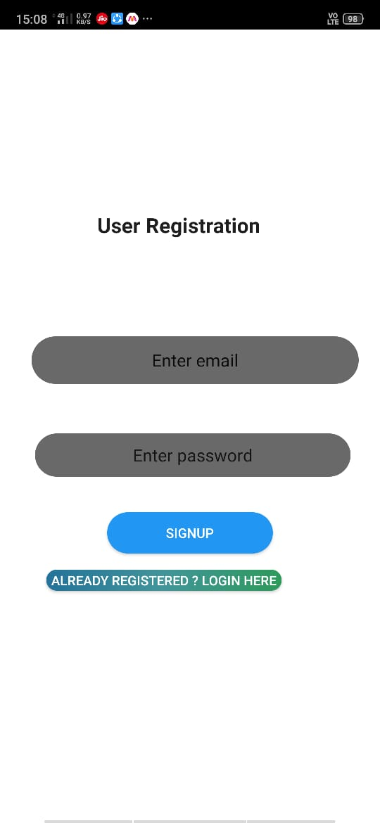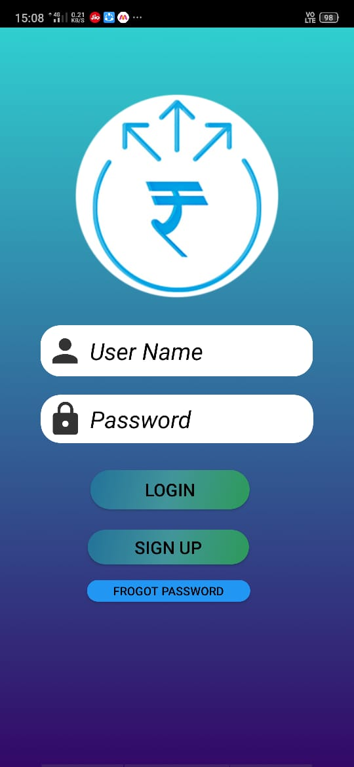

* **Home screen:**

Here, user can see options for viewing groups. The groups are arranged in a list format which makes it easy to view all the groups at a single place.

It also has a Create Group button through which the user can create a new group and invite members.

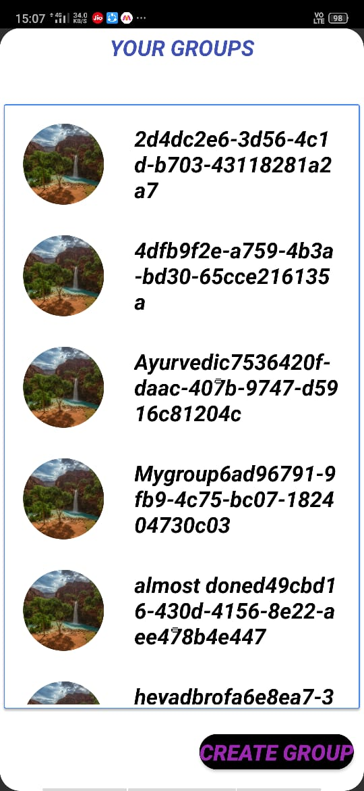

* **Activity Screen:**

After clicking on a particular group, the user is redirected to the activity page. Here, he can perform activities like paying bills, viewing transactions and adding members.

The activities can be performed by using the buttons: Pay, View Transactions and Add Members.

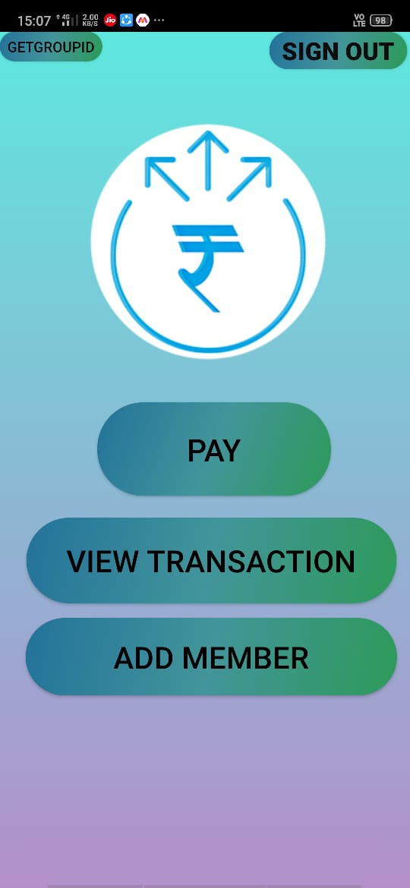

* **Payment Activity:**

The payment activity consists of various payment options like UPI, Paytm and Cash Payment. The user can choose payment option of his choice to complete the transactions.

This page consists of buttons which redirect you to the respective payment options API.

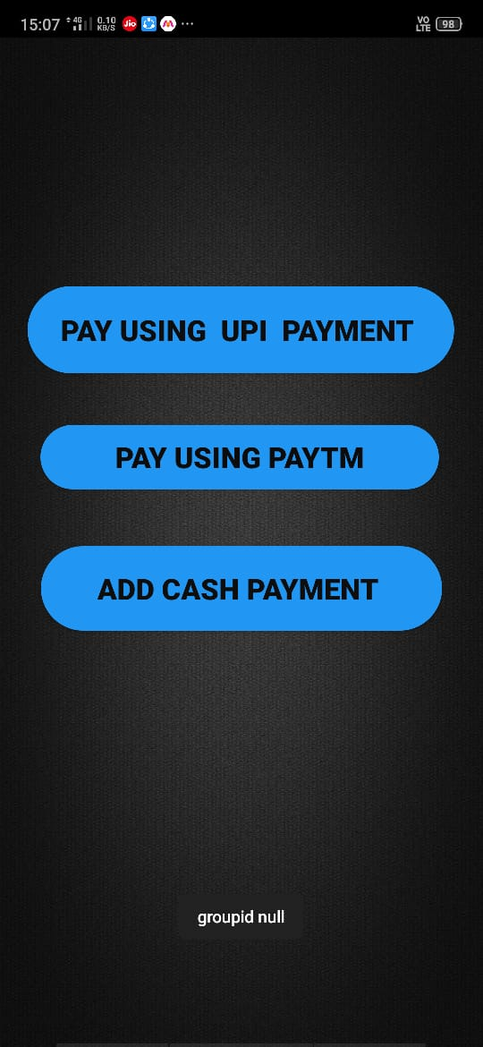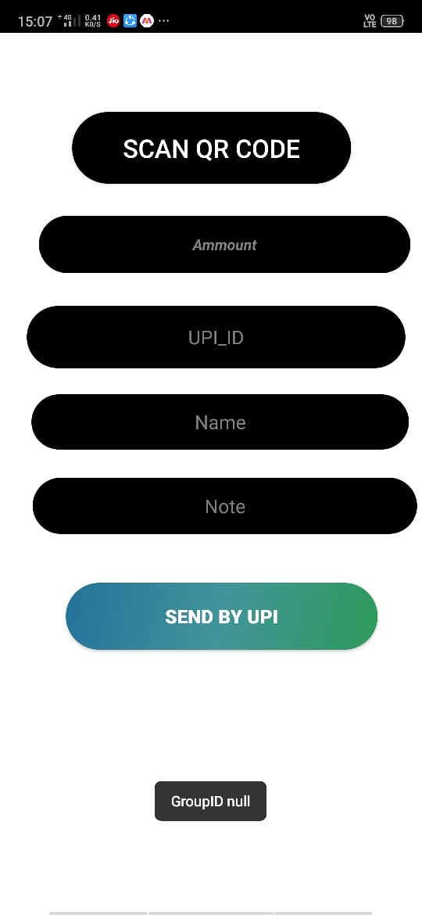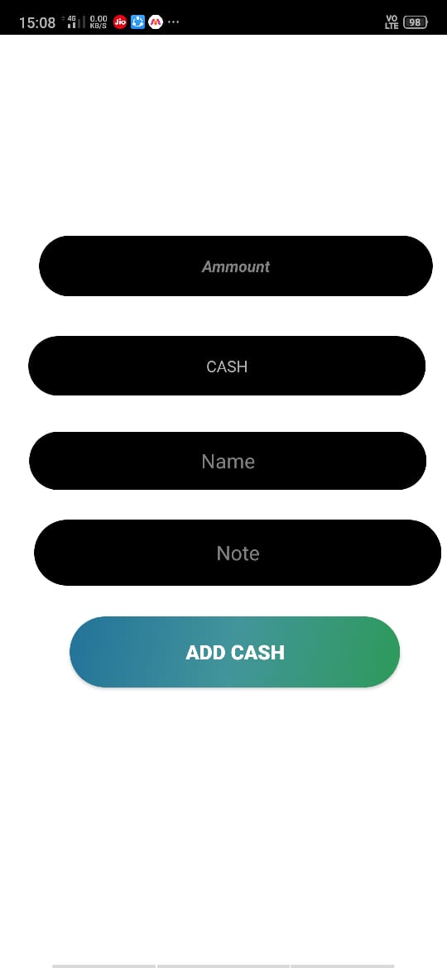

* **View Transactions Activity:**

In this tab two buttons are provided one for personal transactions and another for group transactions.

In personal transactions, user will be able to see his transactions only. In group transactions, all the transactions of multiple users will be shown.

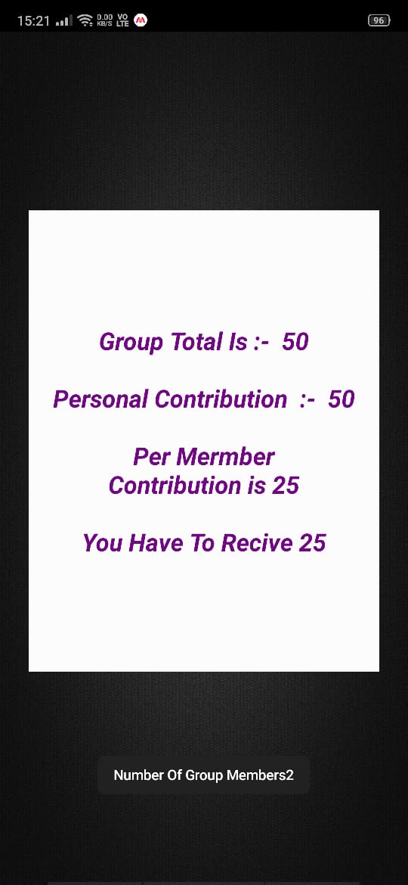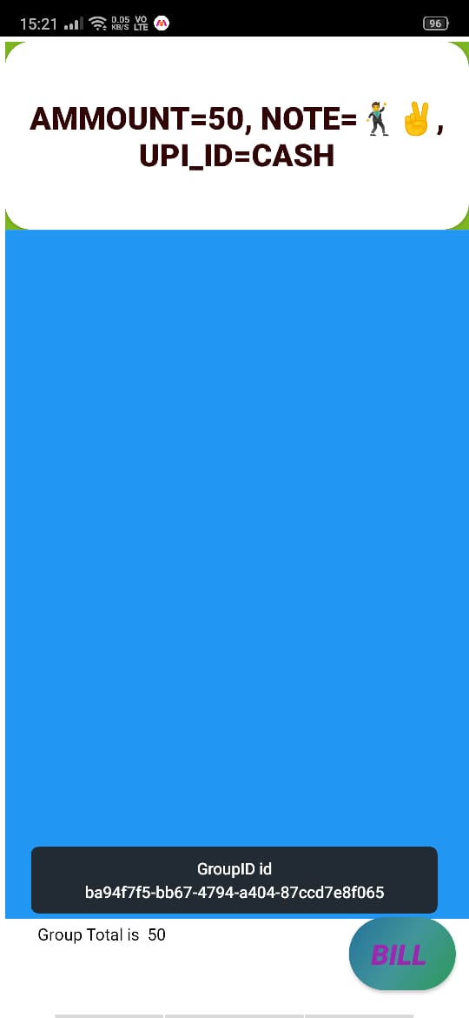

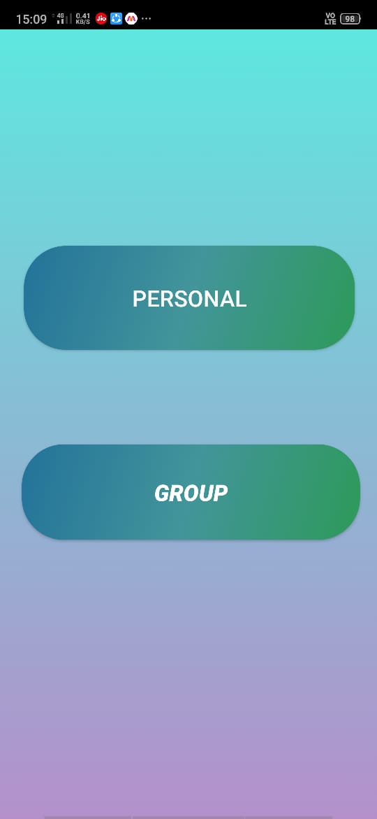

* **Add Members Activity:**

In this activity, we can add new members to our existing group. The method by which we can add a new member is by generating a unique group-id.

The unique group-id is then shared to the person we want to add via WhatsApp, Text Messaging and all other media.

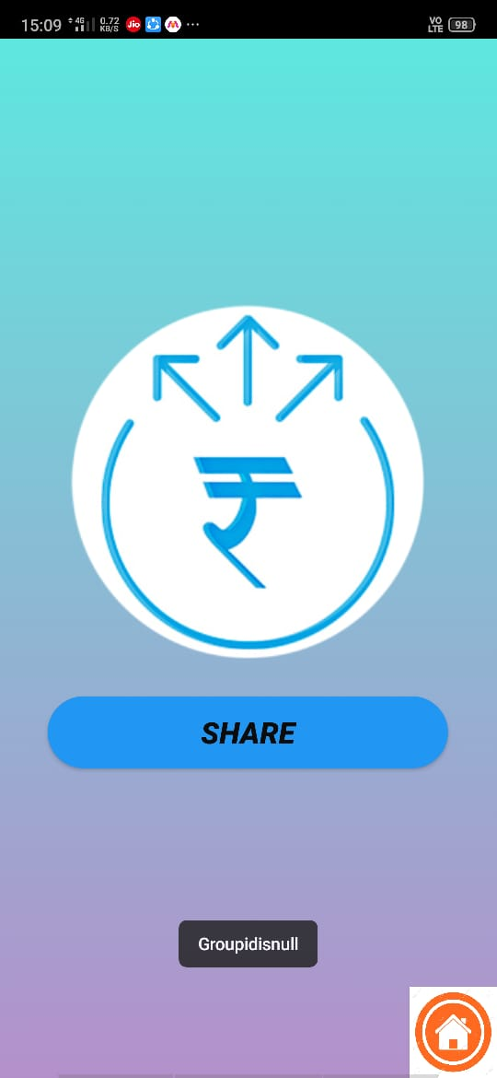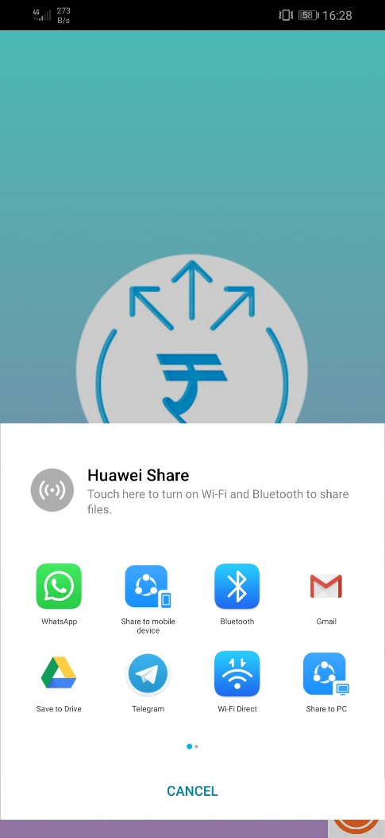

**FUTURE SCOPE**

1. We can edit our user profile.
2. Improve the general management and UI to create a more user-friendly application.
3. We can add more payment options.
4. Can include a wallet for better management of expenses.
5. When the transaction is made, we could record the time and date of it to know exactly when we did the transactions.

**CONCLUSION**

Pay N Split is an app that takes the trouble out of sharing expenses with friends, roommates and everyone else. It does all the math for you because it keeps a running total over time, so you can pay each other back in one big payment instead of a bunch of small ones. It is all organized in one place so everyone can see who they owe money to. No matter if you are sharing a lunch with a friend, watching a movie in a group, paying rent with your roommate or going on a ski trip, there is no more need to worry about money because Pay N Split will do all the work for you fair and square.